Premier University, Chittagong
Department of Computer Science and Engineering
Object-Oriented Design of a Hospital
Medical Equipment Management System
Course Title: Object Oriented Programming
Course Code: CSE 1115
Spring 2026, 3rd Semester – Assignment (CLO2)
Submitted by: Pranta Mohajan
Student ID: [0222510005101025]
Program: B.Sc. in Computer Science and Engineering

1. Introduction
Modern hospitals rely on a wide range of medical equipment — patient monitors, ventilators, infusion pumps, ECG machines, and portable ultrasound devices — to deliver safe and effective patient care. Although these devices differ in function, operating conditions, and maintenance needs, they also share common characteristics such as an identity, an operational status, and a maintenance history. Manually tracking this information across a large and growing equipment inventory is error-prone and does not scale as the hospital acquires new device types.
This report analyzes the given scenario from a software-engineering perspective and proposes an object-oriented design for a Hospital Medical Equipment Management System. The design applies core object-oriented principles — abstraction, encapsulation, inheritance, polymorphism, interfaces, and class relationships — so that the resulting system is correct, maintainable, and easy to extend as new equipment types are introduced.

2. Problem Analysis

2.1 Engineering Problem
The hospital currently has no unified way to track its diverse medical equipment: what devices exist, whether each device is currently safe to use, and when each device was last (or should next be) serviced. Because different devices behave differently but must still be managed through the same hospital-wide process, the core engineering problem is:
How to design a software structure that treats many different, specialized equipment types uniformly for tracking and maintenance purposes, while still allowing each type to define its own operating behavior — and that can absorb new equipment types in the future without redesigning the whole system.

2.2 Major Software Objects
Analyzing the scenario identifies the following major software objects and their responsibilities:
Software Object | Responsibility
MedicalEquipment (abstract) | Base type for every equipment item; holds shared attributes (ID, name, status) and shared behavior (checkStatus, maintenance handling).
PatientMonitor / Ventilator / InfusionPump / ECGMachine / PortableUltrasound | Concrete equipment types; each implements its own version of startOperation() / stopOperation() and any device-specific behavior.
Maintainable (interface) | Contract guaranteeing that any equipment type can be scheduled and maintained in a consistent way.
MaintenanceRecord | Represents a single completed or scheduled maintenance event tied to one equipment item.
MaintenanceScheduler | Coordinates maintenance scheduling across all equipment and reports upcoming/overdue tasks.
Hospital | Owns the overall collection of equipment; adds, removes, and queries equipment on behalf of hospital staff.
EquipmentStatus (enumeration) | Fixed set of valid operational states used by every equipment item.

3. Functional Requirements
Based on the scenario, the proposed system must satisfy the following functional requirements:
ID | Functional Requirement
FR1 | Register new equipment with ID, name, manufacturer, model, and type.
FR2 | Track and update the operational status of each equipment item (Operational / Under Maintenance / Out of Service).
FR3 | Support equipment-specific start and stop operations, each behaving according to the equipment type.
FR4 | Schedule maintenance activities and record completed maintenance history for every equipment item.
FR5 | Generate a list of equipment that is due or overdue for maintenance.
FR6 | Allow hospital staff to view, search, and filter equipment by status or type.
FR7 | Allow new equipment types to be added in the future without modifying existing system code.
FR8 | Maintain a complete, retrievable maintenance history for each equipment item.

4. Object-Oriented Design
The design applies each core OOP principle deliberately, as summarized below.

4.1 Abstraction
An abstract class, MedicalEquipment, captures what every piece of equipment has in common — an ID, name, manufacturer, model, and status — without committing to how any specific device operates. Its startOperation() and stopOperation() methods are declared abstract, forcing every concrete subclass to supply its own meaningful implementation while hiding that implementation detail from the rest of the system.

4.2 Encapsulation
All attributes of MedicalEquipment and its subclasses are kept private or protected and are only reachable through controlled public methods (e.g., checkStatus(), getEquipmentInfo()). This prevents external code from putting an equipment object into an invalid state, such as an operational status that was never actually verified.

4.3 Inheritance
PatientMonitor, Ventilator, InfusionPump, ECGMachine, and PortableUltrasound all extend MedicalEquipment. Each subclass automatically reuses the shared identity, status-tracking, and maintenance logic, and only needs to add attributes and behavior specific to that device (e.g., oxygenLevel for Ventilator, leadCount for ECGMachine).

4.4 Polymorphism
Because every subclass overrides startOperation() and stopOperation() differently, the Hospital and MaintenanceScheduler can hold a simple collection of MedicalEquipment references and call the same method on every item — each object responds according to its own type at runtime. This lets the hospital start, stop, or check all equipment in a single uniform loop, regardless of how many device types exist.

4.5 Interfaces
The Maintainable interface defines a contract — scheduleMaintenance(), performMaintenance(), getNextMaintenanceDate() — that MedicalEquipment implements. This guarantees that every equipment type, present or future, automatically supports maintenance scheduling in a consistent way, independent of its inheritance hierarchy.

4.6 Class Relationships
The design uses five distinct relationships to connect the classes realistically:
Relationship | Between | Meaning
Inheritance (is-a) | MedicalEquipment ← PatientMonitor, Ventilator, InfusionPump, ECGMachine, PortableUltrasound | Each concrete equipment type reuses common attributes/behavior and specializes startOperation()/stopOperation().
Realization | MedicalEquipment ⇢ Maintainable | MedicalEquipment implements the Maintainable contract, so every subclass is maintainable automatically.
Composition | MedicalEquipment ◆ MaintenanceRecord | A maintenance record has no meaning without the equipment it belongs to; records are deleted with the equipment.
Aggregation | Hospital ◇ MedicalEquipment | The hospital manages a collection of equipment, but an equipment item is a meaningful object on its own.
Association | MaintenanceScheduler → MedicalEquipment, Hospital → MaintenanceScheduler | The scheduler works with equipment to plan maintenance; the hospital uses the scheduler as a service.

5. UML Class Diagram
The diagram below represents the complete object-oriented design described above, including inheritance, interface realization, composition, aggregation, and association relationships.
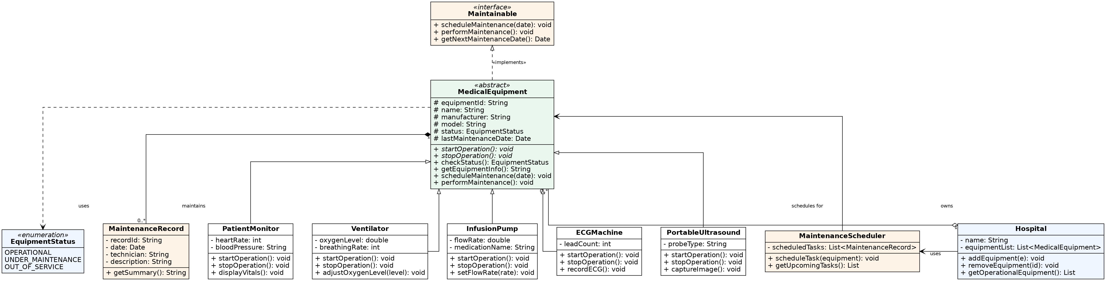
Figure 1: UML Class Diagram – Hospital Medical Equipment Management System

6. Design Explanation
The proposed design directly addresses the engineering problem identified in Section 2:
- Extensibility: A new device type (e.g., a Defibrillator) can be added simply by creating a new subclass of MedicalEquipment that implements startOperation() and stopOperation(). No existing class — Hospital, MaintenanceScheduler, or any other equipment class — needs to change, satisfying the Open/Closed Principle.
- Uniform maintenance tracking: Because Maintainable is implemented once at the MedicalEquipment level, every current and future equipment type is guaranteed to support scheduling and history-keeping consistently, rather than each device team reinventing it.
- Data integrity: Encapsulation ensures an equipment's status and history can only change through its own controlled methods, so the system's records stay trustworthy for safety-critical decisions.
- Simplified operational code: Polymorphism lets the hospital operate on its entire equipment list through one shared interface, instead of writing separate handling code for each of the five (or more) device types.
- Realistic structure: Composition between MedicalEquipment and MaintenanceRecord reflects that a maintenance record only exists because of its equipment, while aggregation between Hospital and MedicalEquipment reflects that equipment is managed by, but conceptually independent of, a specific hospital.
Together, these choices produce a system that is correct for today's five equipment types and resilient to the hospital's future expansion.

7. Conclusion
The hospital's need to manage a growing, diverse set of medical equipment is fundamentally an object-oriented design problem: many specialized behaviors must be handled through one consistent structure. By modeling a common abstract base class, a shared maintenance interface, five specialized equipment subclasses, and supporting classes for maintenance and hospital-level management, the proposed design satisfies all identified functional requirements while remaining easy to extend. This demonstrates that abstraction, encapsulation, inheritance, polymorphism, interfaces, and well-chosen class relationships are not just theoretical concepts but practical tools for solving a real, scalable, safety-relevant engineering problem.

